**Use-Case Glossary**

|  |  |  |
| --- | --- | --- |
| **Use-Case Glossary** | | |
| **Use-Case Name** | **Use-Case Description** | **Participating  Actors and Roles** |
| Create account | This use case describes the event of creating a new account. | Client |
| Enter account | This use case describes the event of a client entering their account and password. | Client |
| Enter event | This use case describes the event of a client add new event into their calendar | Client |
| Check event | This use case describes the event of a client checking in their calendar | Client |
| Text to speech | This use case describes the event of automatically generate a speech from text. | Time |
| Speech to text | This use case describes the event of automatically transferring speech to text | Time |
| Edit event | This use case describes the event of editing event in the calendar | Client |
| Logout | This use case describes the event of logout user’s account | Client |

**Use-Case Model Diagram**

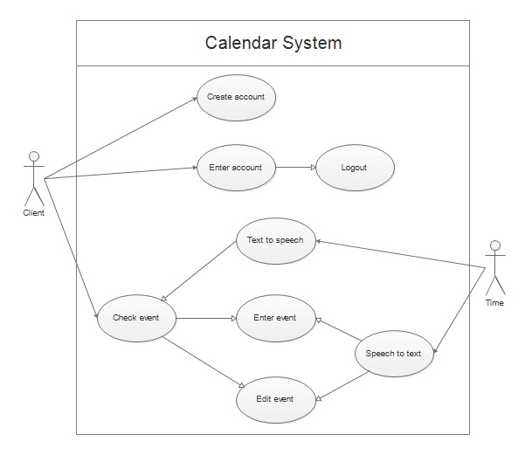

Use-Case Narrative

Calendar System

Author: Wong Ho Long Date:3/5/15

|  |  |  |
| --- | --- | --- |
| Use-Case Name: | Enter event |  |
| Use-Case ID: | FYP-001 |
| Priority: | High |
| Source: |  |
| Primary System Actor: | Client | |
| Primary Business Actor: |  | |
| Other participating Actors: |  | |
| Other Interested Stakeholders: |  | |
| Description: | This use case describes the event of a client add new event into their calendar | |
| Precondition: | The user must have previously logged on so that system can identify the user as a particular client and user must open the calendar interface (check event). | |
| Trigger: | The use case is initiated when the user selects this option from the user interface | |
| Typical Course of Events: | Actor Action | System Response |
| Step 1: This use case is initiated when this user click  Step 3: The user may choose the edit detail option  Step 5: The user inputs all the event information and click the save button. | Step 2: The system responds by displaying a dialog box with title input, save and edit detail.  Step 4: The system responds by displaying a pop-up window with event detail, save and cancel button.  Step 6: The system saves those information and pop up a success message |
| Alternate Courses: | Alt Step 3a: If the user click the save button, the system will saves the title and other ‘detail’ information that by system default. | |
| Conclusion: | This use case concludes when the system saved the event information | |
| Postcondition: | Nope | |
| Business Rules: | Nope | |
| Implementation Constraints and Specifications: | Web programming and Database to be used so clients can use it easily, and client’s input can be stored | |
| Assumptions: | User registered an account | |
| Open Issues: | Nope | |